

**1.INTRODUCTION**

**1.1 A brief description about your projects.**

Let us analyze the Indian agriculture crop production for the data collected from 1997 to 2022. Let us ask interesting questions on existing data get production and aarea statistics and understand more on the Indian agriculture history for crop production.

**1.2 The use of this project.what can be achieved using this.**

Agriculture is the foundation of the Indian economy.the population of india mostly dependes on agriculture for their livelihood and agriculture contributes to 40% of the total GDP of the country

**2.Problem definition and design thinking**

2.2 BRAIN STORM AND IDEATION

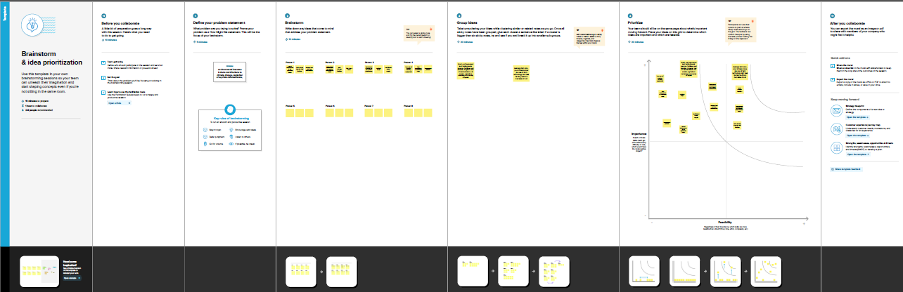

**3. Result**

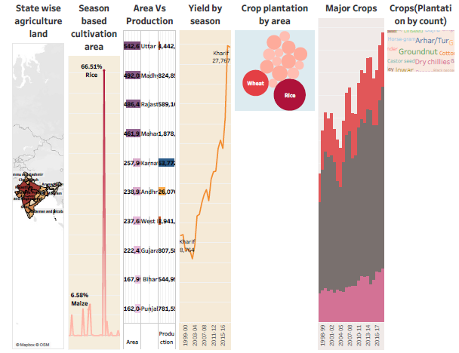

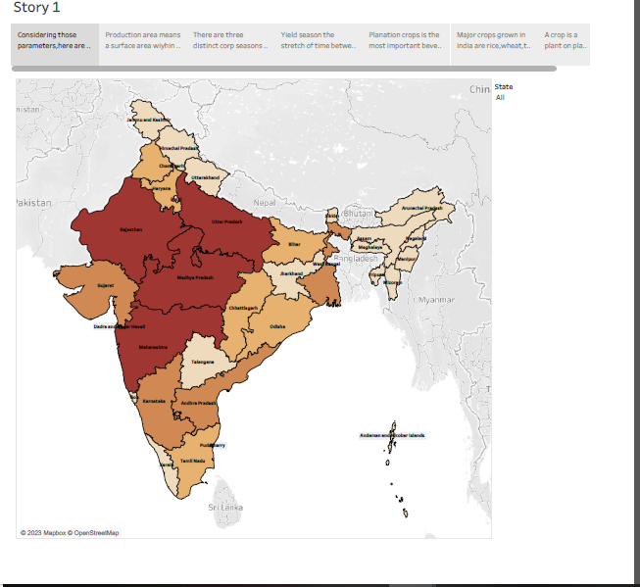

**4. ADVANTAGES AND DISADVANTAGES :**

|  |  |
| --- | --- |
| ADVANTAGES | DISADVANTAGES |
| 1.Agriculture is the mainstay of Indian economy because about 60% of our population depends directly or indirectly on agriculture | 1.Requires expertise and finesse |
| Supplies raw materials to various agro-based 2.industries like sugar,jute,cotton textile and vanaspati industries | Adapting to the significant shift in the 2.environment |
| Improved efficiency | Erosion of soil by heavy rain,floods,insufficient vegetation cover |
| 3.Produces most of the food and foodgrains that we consume | 3.The effect of removing the top soil and its subsequent influence on plant growth |
| 4.Improved crop quality | 4.Bio diversity loss |
| 5.Supporting livelihoods through food,habitat and jobs providing raw materials for food and protects and boiding strong economics through trade | 5.Over used the natural resource base |
| 6.Reduced Environmental Impact | 6.Water pollution |
| 7.Increased to food production | 7.Health risks |
| 8.Economic benefits | 8.Food safety concerns |

**5 APPLICATIONS**

* More than 60% Indian people are engaged in agriculture. But now farmers are afraid to loose their livelihood due new farm laws. As a result thousands of farmers start protesting against these laws. Watch the following video to learn about the causes of huge farmer protests in India.
* Rice is a staple food of 3.5 billon people of the world. But each year insects and many diseases destroy a lot of rice. To cope with situation scientists developed genetically modified crops which will help us to save crops from bacteria, fungi and viruses. Watch the following video to get to know benefits of genetically modified crops in agriculture.
* With the farmers’ strike in full swing in India’s capital , their  importance and their contribution to the [Indian economy](https://en.wikipedia.org/wiki/Economy_of_India) through their  supply of food, fabrics, livestock,etc ,has never been more stark.Life without them is unthinkable!
* These  farmers and other associated people in agriculture need to have multiple skills to run this multifaceted business. Raw materials ( like seeds, tools, fertilizers ) must be purchased, certain services must be sought and products sold. All this entails an understanding of the agribusiness market and economics to ensure a profit.
* Farmers work with individuals and communities to supply the needs of their farm and sell their products. Farmers must manage their funds, compare prices, and make wise financial decisions.
* Farmers use mathematical  skills and science in their day-to-day farm activities.
* For example, farmers use mathematical skills to estimate the seed amount needed, the cost to plant their crop based on the area of cultivable land they possess, to purchase equipment or tools needed and make payments for various purchases. Mathematical calculation is essential for determining the amount of tax that needs to be paid and also to track the weight of cattle, the milk the cows produce and the crop yield per season, etc.
* The nature lab facility at our [Babaji Vidhyasharam School Chennai](https://www.babajividhyashram.org/" \o "CBSE School in Chennai" \t "_blank) is an excellent place to witness the application of math and science skills in real life when growing vegetables. Math and science both are integrated and it's amazing how we can apply the textual knowledge practically.
* The nature lab constructed over half an acre land is designed for cultivating vegetables organically using aquaponics. The circular cultivating area receives water from a fish tank. This system itself requires a lot of calculation. The reason behind the cultivable bed being in the shape of a circle and not a square, the calculation of the flow of water to each sector of the circle.....and so on. The calculations do not stop here.
* Indias arable land area of 159 .7 million hectares is the second largest in the world after the united status. Rice is sown the largest area in india.

**6 CONCLUSION**

Agriculture is the art and science of cultivating the soil , growing crops , and raising livestock.Agriculture provides most of the worlds food and fabrics.

**7 FUTURE SCOPE**

* Future agriculture will use sophisticates technologieas such as roborts ,temperature and moisture sensors ,aerial images , and GPS techonology.
* agriculture sector is the largest sector with 49% of country's population works in Agriculture sector by occupation. India is also a developing country with about 16% of its GDP is contributed by this sector.